**Cola Wars continue: Coke and Pepsi in 2010**

**Q1- Why, historically, has the soft drink industry been so profitable?**

Soft drink industry is on a continuous rise since few decades. Not only in USA, but the consumption of soft drinks has increased in the whole world. One indicator of this increasing consumption is that in 1970, Americans consumed 23 Gallons of CSDs which increased by an average of 3% every year for the next 30 years. With the increasing consumption, the key players in the industry have made huge profits and are sustaining them.

Soft drink industry has been profitable historically because of continuous innovation, extensive marketing, low production cost, strong supply chain, and long rivalries.

**Continuous innovation:**

Soft drink industry players made continuous innovations by the time to keep the market updated with the trends, regulations, and local tastes. In later period of last decade, when USA states started taking and banning the corn syrup drinks, Coke and Pepsi fought this by introducing alternative non-CSD formulas for their sweetening their drinks. Coke and Pepsi also targeted other customer segments by diversifying product lines. Coke introduced diet coke. Caffeine-Free Coke, Cherry Coke and 11 other variants of the original Coke. While, Pepsi introduced Lemon-Lime Slice, Caffeine-Free Pepsi-Cola, 13 variants in 1980s.

Coke and Pepsi did not restrict their innovation to be exempted from regulations and taxes, but also to be adapt to the local people. Coke offered a mixture of sprite and green tea by the name of sprite tea while Pepsi blended herbs to make a new product offering in China. In Russia, Coke and Pepsi entered the juice market. While in India and China, Coke introduced small returnable glass bottles to assist reaching to the poor people together with increasing revenue per ounce.

**Extensive marketing:**

Coke and Pepsi kept their brands active all the time through Heavy investment in product development, market research, and advertising. They spend millions of dollars into marketing of their products to capture more customers. Coke and Pepsi sponsored World cup events, hire actors as brand ambassadors and introduced huge discounts. Soft drink manufacturers have branded their products as the important component of the people lives. Coke and Pepsi positioned Soft drink beverages as the icon among young people through campaigns like of Pepsi Generation campaign in 1963. Youth has always been their main target customers.

**Low production cost:**

One most important thing that kept soft drink industry profitable all the time is the low production cost. Companies incur a very little cost on production. Main costs include product development, market research, and advertising. In the product cost, concentrated syrup is main cost.

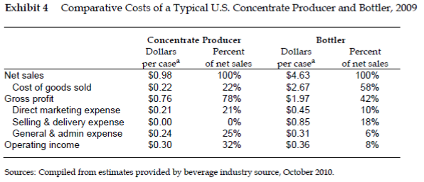

From the exhibit 4, we can see that among advertising and promotion covers more than 50% of the total costs. This low production cost results in high profit margins which motivated the companies to enter into the business.

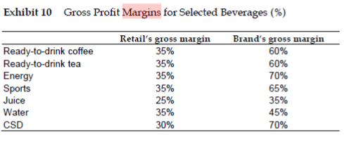

**Strong supply chain:**

One of the main factor in the industry success s the good supply chain. Pepsi and Coke both focused a lot into managing good relationships with their distributers. Coke CEO itself met with the large distributes of Coke at dinner. Coke spent Pepsi acquirees of bottling of its bottlers in 1980s. Coke and Pepsi also monitors the shelves of their retailers like of Walmart. Route delivery salespeople managed the CSD brand in stores by securing shelf space, stacking CSD products, positioning the brand’s trademarked label, and setting up point-of-purchase or end-of-aisle displays. Packaging has been one of the key focus of the industry. For example, in 1980 Pepsi has more than 17 packaging variants.

**Long rivalries:**

Decades long rivalry of the top 2 leading brands has kept the soft drink industry main attention of the customers. The war which started from a Pepsi Challenge campaign in 1950s to international market war in 2000s. Both companies remain competitive with each other all the time since 1950s. This rivalry has caused price reductions but overall, it proved to be the main reason of the expansion and innovation in soft drink industry. The huge investments in advertising campaigns over the decades strengthen the industry so much that now every other person around the world has heard of Pepsi and Coke.

**Q2- Compare the economics of the concentrate business to that of the bottling business. Why is the profitability so different?**

Concentrate Business:

* Suppliers have major role.
* Requires less investment.
* Major costs are the advertising and R&D costs.

Bottlers Business:

* Buyers have major power
* Require large capital investment for the products of similar types and sizes.
* Operational costs make up the major portion of expenditures.

In market, both work in tandem with each other to support businesses.

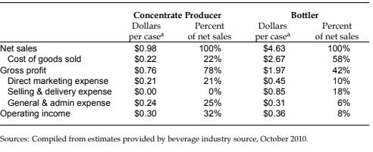

**Q3- How can Coke and Pepsi sustain their profits in the wake of flattering demand and the growing popularity of non-CSDs?**

It is true that non-CSD industry is rising as the time is progressing, but non-CSD industry is still far behind compared to Pepsi and Coke.

Although the major product of Pepsi and Coke is soda but they have entered the non-CSD market too after the imposition of taxes on CSD beverages in 2008. Even if they do not enter the non-CSD market, con-CSD drinks cannot the compete Pepsi and Coke on the market capitalization, brand equity and customer loyalty which both Pepsi and Coke have built during the decades. Continuous innovation in the products, diversification of product lines and campaigns are needed for the consistent growth of the industry and to be cope up with the flattening demand of Pepsi and Coke. With the rising environmental concerns, Pepsi and Coke often face critic for the bottle pollution. The recycling campaigns need to be more enhanced.